

LEARNER GUIDE
For
Agentic AI for Social Media Marketing
TGS-2020505996
TSC: Social Media Marketing · HAS-OTO-4007-1.1
Conducted by Tertiary Infotech Academy Pte Ltd · UEN 201200696W
Version v15.0 · 11 September 2026

Document Version Control Record
Version Number | Effective Date | Summary of Included Changes | Author
v15.0 | 11 September 2026 | Rebuilt from the approved v14 Facebook deck; expanded with agentic architecture, governance, current controls, ten self-contained labs and mock data. | Dr Alfred Ang

Table of Contents
Document Version Control Record 3
Table of Contents 3
1. Course Overview 4
Learning Outcomes 4
Assessment 4
2. Responsible Agentic Marketing Operating Model 4
3. Topic 01: Plan an Agentic Social Media Campaign 4
Translate Business Goals into a KPI Tree 4
Encode a Persona as Evidence, Not Fiction 5
Model the Buyer Journey as Observable States 5
Build a Social Media Audit Inventory 6
Score Marketing Opportunities Transparently 6
Design the Marketing Agent Architecture 6
Write a Tool Contract the Agent Can Obey 7
Set Policy Boundaries Before Automation 7
Lab 1: Build an Agent-Ready Campaign Charter 7
Lab 2: Create an Evidence-Based Persona and Journey Agent 9
4. Topic 02: Create Campaigns with Governed Agents 10
Represent Campaign, Ad Set, and Ad 10
Turn a Creative Brief into Structured Inputs 11
Encode Brand Voice as Testable Rules 11
Build Audiences with Purpose Limitation 11
Generate Content Through a Review Pipeline 12
Place a Human Approval Gate Before Publish 12
Choose Placement and Format with a Matrix 12
Design a Clean Campaign Experiment 13
Lab 3: Build a Brand-Safe Content Brief Agent 13
Lab 4: Assemble a Governed Campaign Package 15
5. Topic 03: Measure Performance and Agent Decisions 16
Map the Measurement Event Pipeline 16
Calculate Reach, CTR, CVR, CPL and ROAS 17
Build a Funnel with Diagnostic Rates 17
Separate Attribution from Incrementality 17
Design a Reporting Schema for Agents 18
Detect Anomalies with Thresholds and Context 18
Build Retargeting with Consent and Suppression 19
Observe the Agent, Not Just the Campaign 19
Lab 5: Compute a Campaign Measurement Scorecard 19
Lab 6: Build a Listening and Anomaly Triage Agent 21
6. Topic 04: Optimize Campaigns with Controlled Experiments 22
Run the Observe–Diagnose–Act Loop 22
Use Practical Significance in A/B Decisions 23
Reallocate Budget with Marginal Return 23
Detect Creative Fatigue 23
Control Audience Overlap and Frequency 24
Schedule Content with Dependencies 24
Compare Platforms with a Feasibility Matrix 25
Define Rollback and Kill-Switch Rules 25
Lab 7: Evaluate an A/B Test and Budget Decision 25
Lab 8: Orchestrate an Approval-Aware Content Calendar 27
7. Topic 05: Manage Communities with Human Oversight 28
Route Community Messages by Intent and Risk 28
Evaluate Sentiment with Confidence 29
Apply a Moderation Decision Ladder 29
Manage UGC Rights and Permissions 29
Escalate Reputation Risk with Evidence 30
Build an Advocacy Flywheel 30
Evaluate Organisational Impact 30
Operate an AI Governance and Oversight Loop 31
Lab 9: Triage Community Messages with Human Oversight 31
Lab 10: Capstone: Operate a Governed Agentic Campaign 33
8. Capstone Evidence Checklist 34
9. Sources and Version Notes 35

1. Course Overview
This 2-day, 16-hour WSQ course preserves the approved Social Media Marketing competency coverage while teaching learners to plan, create, measure, optimize and govern social campaigns with bounded AI agents and human oversight.

Learning Outcomes
- LO1: Develop a plan for a Facebook social media marketing campaign.
- LO2: Evaluate social market opportunities for a Facebook campaign.
- LO3: Monitor Facebook social media marketing performance.
- LO4: Determine campaign feasibility by optimizing Facebook advertisements.
- LO5: Evaluate campaign usage and its impact on the organisation.
- LO6: Establish measurable social media marketing objectives.

Assessment
Written Assessment (SAQ): 10 open-ended questions, 60 minutes. Practical Performance: 5 applied tasks, 60 minutes. Both are open book. Submit completed answers on the LMS: https://lms-tms.tertiaryinfotech.com/

2. Responsible Agentic Marketing Operating Model
An agentic workflow observes inputs, plans bounded work, calls approved tools, evaluates outputs, requests human approval for consequential actions and records evidence. Agents support decisions; accountable people retain ownership of objectives, data, claims, budgets, publication and community responses.
Layer | Required evidence | Human control
Objective | KPI tree and guardrails | Campaign owner approves
Data | Purpose, consent, lineage and retention | DPO/policy review
Agent | Prompt, tool contract, model/version and trace | Risk-tier approval
Action | Draft, score, schedule or recommendation | Publish/pause gates
Outcome | Metrics, exceptions and incident record | Review and rollback

3. Topic 01: Plan an Agentic Social Media Campaign
WSQ mapping: A1 · K1 · K2. Legacy coverage retained: Plan a Facebook Social Media Marketing Campaign.

Translate Business Goals into a KPI Tree
Technical anchor: MODEL · K1/A6. The mechanism runs through Business outcome → Marketing objective → Leading signals → Lagging signals → Decision rule.
Field | Worked value | Interpretation
objective_id | OBJ-01 | Trace every action
baseline | 120 leads/month | Starting point
target | +25% in 90 days | Measurable delta
guardrail | CPL <= SGD 24 | Economic bound

Failure, control and recovery
Failure mode | Observable signal | Control / recovery
Vanity metric | Likes rise but leads do not | Use KPI tree
No baseline | Target cannot be evaluated | Record source period
Agent goal drift | Optimizes clicks only | Lock objective hierarchy
Overclaim | Causal language without test | Label inference
Worked evidence: The 90-day target requires a 25% lift from the 120-lead baseline.

Encode a Persona as Evidence, Not Fiction
Technical anchor: EVIDENCE · K1/A1. The mechanism runs through Collect → Separate → Structure → Score → Approve.
Field | Worked value | Interpretation
persona_id | P-SG-01 | Stable key
evidence | 12 interviews | Provenance
need | Lower energy bills | Message input
confidence | 0.78 | Review priority

Failure, control and recovery
Failure mode | Observable signal | Control / recovery
Stereotype | Trait lacks evidence | Remove or qualify
PII leakage | Names in prompt | Aggregate and redact
Stale profile | Data older than 12 months | Refresh study
False certainty | No confidence score | Mark hypothesis
Worked evidence: Use multiple evidence sources; no single source is a complete persona.

Model the Buyer Journey as Observable States
Technical anchor: MODEL · K1/A1. The mechanism runs through Unaware → Aware → Considering → Deciding → Customer.
Field | Worked value | Interpretation
journey_state | considering | Current state
trigger | comparison guide | Transition cue
evidence | pricing-page visit | Observable signal
next_best_action | case study | Agent proposal

Failure, control and recovery
Failure mode | Observable signal | Control / recovery
Skipped state | Hard sell to unaware user | Use education
Weak signal | One click treated as intent | Require corroboration
Dark pattern | Artificial urgency | Ethics review
State lock | Never re-evaluated | Time-decay signals
Worked evidence: Stage conversion reveals where the agent should intervene, not just final sales.

Build a Social Media Audit Inventory
Technical anchor: ARTIFACT · K1/K2. The mechanism runs through Discover → Verify → Measure → Classify → Assign.
Field | Worked value | Interpretation
asset_id | page_0042 | Unique asset
owner | Marketing Ops | Accountability
access | editor | Least privilege
status | fix | Action queue

Failure, control and recovery
Failure mode | Observable signal | Control / recovery
Orphaned asset | No owner | Suspend publishing
Excess privilege | Shared admin account | Role-based access
Missing baseline | No comparable window | Export 90 days
Duplicate page | Confused audience | Consolidate
Worked evidence: Most assets can be retained; fixes and retirement need accountable owners.

Score Marketing Opportunities Transparently
Technical anchor: FORMULA · A2/A4. The mechanism runs through Define criteria → Weight → Score → Sensitivity → Recommend.
Field | Worked value | Interpretation
reach | 4 × 25% | Audience scale
brand_fit | 5 × 30% | Message alignment
cost | 3 × 25% | Budget feasibility
risk | 4 × 20% | Control burden

Failure, control and recovery
Failure mode | Observable signal | Control / recovery
Hidden weighting | Recommendation cannot be audited | Publish rubric
Double count | Reach and impressions overlap | Separate constructs
Agent bias | Favors familiar channels | Blind channel names
Single score | Masks uncertainty | Show sensitivity
Worked evidence: Influencer, paid social, and brand collaboration can be compared with the same rubric.

Design the Marketing Agent Architecture
Technical anchor: ARCH · K3/A1. The mechanism runs through Observe → Plan → Act → Check → Learn.
Field | Worked value | Interpretation
goal | OBJ-01 | Mission boundary
tool_allowlist | draft, score | Permitted actions
approval_gate | before_publish | Human control
trace_id | run-2026-0911 | Audit evidence

Failure, control and recovery
Failure mode | Observable signal | Control / recovery
Over-autonomy | Agent can publish | Remove publish permission
Tool injection | Content alters instructions | Separate data/instructions
Memory poisoning | Unreviewed feedback persists | Approved writes only
Silent failure | No trace | Structured run log
Worked evidence: Planning, creation, review, and measurement remain explicit stages.

Write a Tool Contract the Agent Can Obey
Technical anchor: CONFIG · K2/K3. The mechanism runs through Name → Input schema → Precondition → Output schema → Error route.
Field | Worked value | Interpretation
tool | draft_post | Clear capability
channel | facebook | Enumerated input
max_claims | 3 | Bounded output
status | needs_review | Safe default

Failure, control and recovery
Failure mode | Observable signal | Control / recovery
Vague tool | Unexpected action | Narrow verb
Free-text input | Unvalidated data | Schema validation
No idempotency | Duplicate posts | request_id
No error class | Infinite retry | Typed errors
Worked evidence: Success, review, validation error, and escalation should be measurable.

Set Policy Boundaries Before Automation
Technical anchor: CONTROL · K2/K4/K5/K6. The mechanism runs through Classify → Permit → Require → Log → Retain.
Field | Worked value | Interpretation
data_class | internal | Handling rule
claim_source | approved catalog | Grounding
reviewer_role | campaign_owner | Accountability
retention_days | 180 | Lifecycle

Failure, control and recovery
Failure mode | Observable signal | Control / recovery
Personal data | Uploaded without consent | Redact/aggregate
IP risk | Unlicensed creative | Rights register
Misleading claim | Unsupported superlative | Evidence requirement
Platform breach | Automation violates terms | Approved interface only
Worked evidence: Most drafts pass; review, revision, and rejection remain visible outcomes.

Lab 1: Build an Agent-Ready Campaign Charter
Mappings: LO1 · LO6 · A1 · A6 · K1 · K2

Goal
Use the supplied mock data to produce campaign_charter.json and KPI decision table and demonstrate the mapped abilities under human oversight.

Scenario and deliverable
Lumina Living will launch an energy-saving home kit in Singapore with a 90-day lead target.
Produce: campaign_charter.json and KPI decision table
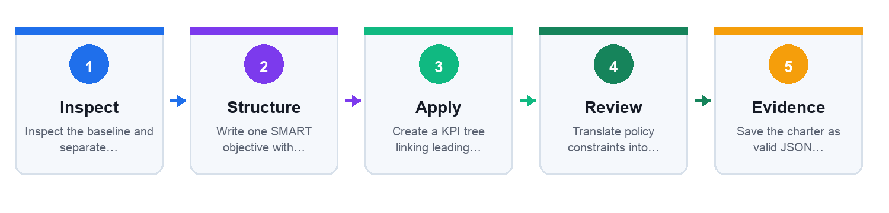

Before you begin
Open the individual lab folder and inspect every file in mock_data/. Use only the supplied mock data. Create a working copy of each output artifact inside the same lab folder.

Detailed step-by-step procedure
- Inspect the baseline and separate business outcomes from channel metrics.
Evidence to retain for Step 1: the changed field, formula, decision rationale or approval record. Do not use a screenshot as a substitute for editable evidence.
- Write one SMART objective with baseline, target, deadline and owner.
Evidence to retain for Step 2: the changed field, formula, decision rationale or approval record. Do not use a screenshot as a substitute for editable evidence.
- Create a KPI tree linking leading indicators to the final outcome.
Evidence to retain for Step 3: the changed field, formula, decision rationale or approval record. Do not use a screenshot as a substitute for editable evidence.
- Translate policy constraints into machine-checkable guardrails.
Evidence to retain for Step 4: the changed field, formula, decision rationale or approval record. Do not use a screenshot as a substitute for editable evidence.
- Save the charter as valid JSON using the provided schema.
Evidence to retain for Step 5: the changed field, formula, decision rationale or approval record. Do not use a screenshot as a substitute for editable evidence.
- Peer-review whether every proposed action is traceable to an objective and policy.
Evidence to retain for Step 6: the changed field, formula, decision rationale or approval record. Do not use a screenshot as a substitute for editable evidence.

Test it — Verification
- Objective includes baseline 120 leads and a 90-day target.
- CPL guardrail is explicit and numerically testable.
- Publishing permission defaults to human approval.
- No personal data is included in the charter.

Troubleshooting
- If the objective is vague, add a metric, baseline, target and deadline.
- If a guardrail is prose-only, rewrite it as a field/operator/value rule.

Cleanup
- Remove any real client identifiers.
- Keep only the mock files and final charter in the lab folder.
Full lab folder: labs/lab-01-campaign-charter/

Lab 2: Create an Evidence-Based Persona and Journey Agent
Mappings: LO1 · LO2 · A1 · A2 · K1

Goal
Use the supplied mock data to produce persona.json, journey.csv and opportunity_score.csv and demonstrate the mapped abilities under human oversight.

Scenario and deliverable
Lumina Living needs a defensible persona and buyer journey for its energy-saving kit.
Produce: persona.json, journey.csv and opportunity_score.csv
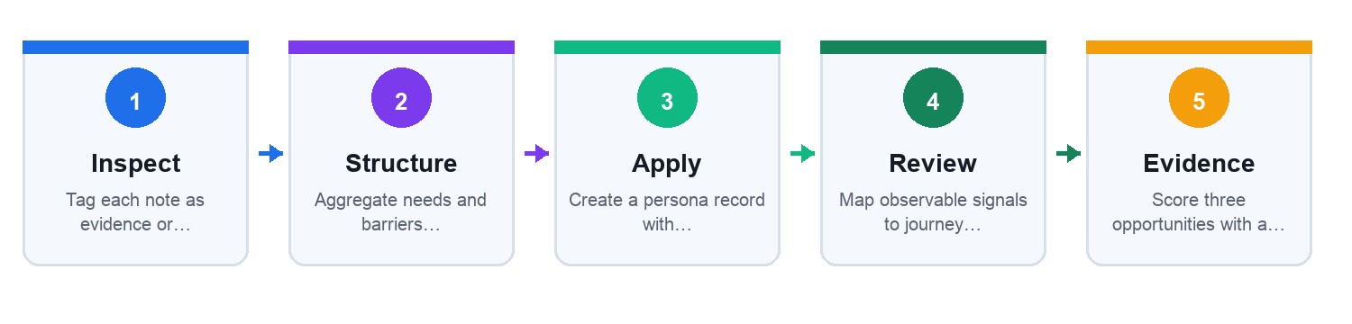

Before you begin
Open the individual lab folder and inspect every file in mock_data/. Use only the supplied mock data. Create a working copy of each output artifact inside the same lab folder.

Detailed step-by-step procedure
- Tag each note as evidence or hypothesis.
Evidence to retain for Step 1: the changed field, formula, decision rationale or approval record. Do not use a screenshot as a substitute for editable evidence.
- Aggregate needs and barriers without retaining names.
Evidence to retain for Step 2: the changed field, formula, decision rationale or approval record. Do not use a screenshot as a substitute for editable evidence.
- Create a persona record with provenance and confidence fields.
Evidence to retain for Step 3: the changed field, formula, decision rationale or approval record. Do not use a screenshot as a substitute for editable evidence.
- Map observable signals to journey states and next-best content.
Evidence to retain for Step 4: the changed field, formula, decision rationale or approval record. Do not use a screenshot as a substitute for editable evidence.
- Score three opportunities with a weighted rubric totaling 100%.
Evidence to retain for Step 5: the changed field, formula, decision rationale or approval record. Do not use a screenshot as a substitute for editable evidence.
- Document where human validation is required.
Evidence to retain for Step 6: the changed field, formula, decision rationale or approval record. Do not use a screenshot as a substitute for editable evidence.

Test it — Verification
- Every persona claim points to at least one mock evidence row.
- No invented demographic is presented as fact.
- Journey states use observable signals.
- Opportunity weights total 100%.

Troubleshooting
- If a claim has no source, mark it as a hypothesis.
- If scores tie, run a weight-sensitivity check rather than forcing a winner.

Cleanup
- Delete scratch prompts containing unredacted notes.
- Retain only aggregated persona and journey artifacts.
Full lab folder: labs/lab-02-persona-journey-agent/

4. Topic 02: Create Campaigns with Governed Agents
WSQ mapping: A2 · K3 · K4. Legacy coverage retained: Create a Facebook Social Media Marketing Campaign.

Represent Campaign, Ad Set, and Ad
Technical anchor: ARCH · K8/A1. The mechanism runs through Campaign → Ad set → Ad → Delivery → Result.
Field | Worked value | Interpretation
campaign.objective | LEADS | Optimization goal
adset.budget | SGD 50/day | Spend control
ad.format | vertical_video | Creative contract
event | lead_submitted | Outcome

Failure, control and recovery
Failure mode | Observable signal | Control / recovery
Wrong level | Budget set on ad | Respect hierarchy
Objective mismatch | Clicks for lead goal | Optimize for outcome
Missing destination | Broken journey | Preflight URL
Naming drift | No traceability | Naming convention
Worked evidence: Prospecting, retargeting, and experimentation budgets should be explicit.

Turn a Creative Brief into Structured Inputs
Technical anchor: SCHEMA · K1/K3. The mechanism runs through Audience → Promise → Proof → Action → Constraints.
Field | Worked value | Interpretation
audience_id | P-SG-01 | Persona link
proof_id | CASE-014 | Source trace
cta | Book a demo | Outcome
aspect_ratio | 9:16 | Placement fit

Failure, control and recovery
Failure mode | Observable signal | Control / recovery
Brief stuffing | Too many messages | One promise
Missing proof | Hallucinated claim | Required source ID
Tone conflict | Brand mismatch | Voice rubric
Format mismatch | Crop hides CTA | Safe-zone check
Worked evidence: Message clarity and proof should outrank novelty alone.

Encode Brand Voice as Testable Rules
Technical anchor: CONFIG · K2/K6. The mechanism runs through Collect → Extract → Specify → Test → Approve.
Field | Worked value | Interpretation
warmth | 4/5 | Desired tone
formality | 3/5 | Register
banned_phrase | guaranteed | Claims control
reading_level | Grade 8 | Accessibility

Failure, control and recovery
Failure mode | Observable signal | Control / recovery
Style mimicry | Copies competitor | Use own examples
Ambiguous tone | Reviewer disagreement | Anchored scale
Overconstraint | Robotic copy | Prioritize rules
Unversioned rubric | Inconsistent runs | voice_version
Worked evidence: A measurable rubric separates pass, edit, escalate, and reject outcomes.

Build Audiences with Purpose Limitation
Technical anchor: CONTROL · K5/A2. The mechanism runs through Purpose → Minimize → Transform → Match → Expire.
Field | Worked value | Interpretation
purpose | campaign retargeting | Notification
fields | email_hash | Minimized identifier
consent | marketing_opt_in | Legal basis
expiry | 2026-12-31 | Retention limit

Failure, control and recovery
Failure mode | Observable signal | Control / recovery
Purpose creep | List reused | Purpose-bound ID
Raw identifier | Plain email exported | Hash before transfer
No withdrawal | Opt-out ignored | Suppression list
Sensitive inference | Proxy discrimination | Feature review
Worked evidence: Validation and consent filters reduce the usable audience before matching.

Generate Content Through a Review Pipeline
Technical anchor: RUNTIME · K3/K6. The mechanism runs through Retrieve → Draft → Critique → Revise → Approve.
Field | Worked value | Interpretation
brief_id | BR-027 | Input trace
variant_count | 3 | Bounded generation
policy_score | 0.94 | Automated check
release_status | approved | Human decision

Failure, control and recovery
Failure mode | Observable signal | Control / recovery
Ungrounded fact | No source ID | Reject claim
Self-approval | Same agent scores itself | Independent checker
Prompt injection | UGC alters task | Quote as data
Variant collapse | Near duplicates | Similarity threshold
Worked evidence: Only approved variants move from draft to policy pass, human review, and release.

Place a Human Approval Gate Before Publish
Technical anchor: HITL · K2/K4. The mechanism runs through Draft ready → Route → Inspect → Decide → Publish.
Field | Worked value | Interpretation
risk_tier | medium | Routing
review_sla | 4 hours | Operational target
decision | approve_with_edit | Outcome
reviewer_id | role:brand_owner | Accountability

Failure, control and recovery
Failure mode | Observable signal | Control / recovery
Rubber stamp | Very low review time | Sample audit
No fallback | Reviewer unavailable | Backup role
Post-review mutation | Published copy differs | Content hash
Hidden rejection | No rationale | Reason code
Worked evidence: Edits and rejections are useful control signals, not workflow failures.

Choose Placement and Format with a Matrix
Technical anchor: MODEL · K3/A4. The mechanism runs through Outcome → Audience context → Asset fit → Delivery option → Test.
Field | Worked value | Interpretation
placement | reels | Inventory
ratio | 9:16 | Creative fit
safe_zone | pass | Message visibility
optimization | lead | Delivery goal

Failure, control and recovery
Failure mode | Observable signal | Control / recovery
One-size asset | CTA cropped | Placement variants
Manual overfit | Delivery constrained | Test automation
Metric mismatch | Views treated as leads | Outcome KPI
No control | Cannot attribute lift | Experiment design
Worked evidence: Short vertical video, carousel, and static image should be evaluated on comparable outcomes.

Design a Clean Campaign Experiment
Technical anchor: FORMULA · K7/A2. The mechanism runs through Hypothesis → Variable → Control → Run → Decide.
Field | Worked value | Interpretation
hypothesis | video improves CVR | Testable claim
primary_metric | conversion_rate | Decision metric
minimum_lift | 10% | Practical threshold
stop_rule | >= 500 clicks/cell | Stability

Failure, control and recovery
Failure mode | Observable signal | Control / recovery
Peeking | Stop on early winner | Fixed rule
Multiple changes | Causality unclear | One variable
Unequal audience | Biased cells | Random split
Novelty effect | Short run | Adequate duration
Worked evidence: Variant B shows lift, but the sample and decision threshold determine action.

Lab 3: Build a Brand-Safe Content Brief Agent
Mappings: LO2 · A2 · K2 · K3 · K4 · K6

Goal
Use the supplied mock data to produce content_briefs.jsonl and review_rubric.csv and demonstrate the mapped abilities under human oversight.

Scenario and deliverable
Create channel-ready briefs for Lumina Living while preventing unsupported claims and brand drift.
Produce: content_briefs.jsonl and review_rubric.csv
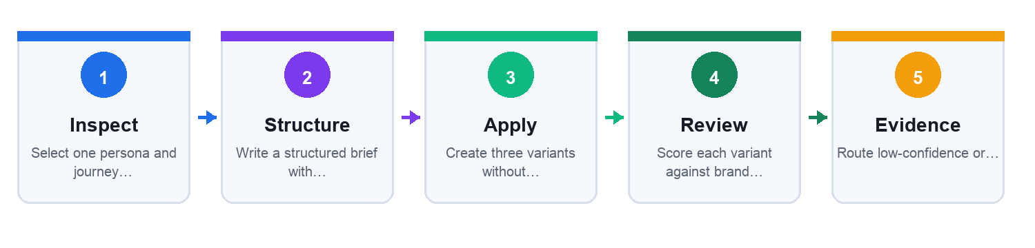

Before you begin
Open the individual lab folder and inspect every file in mock_data/. Use only the supplied mock data. Create a working copy of each output artifact inside the same lab folder.

Detailed step-by-step procedure
- Select one persona and journey state from Lab 2.
Evidence to retain for Step 1: the changed field, formula, decision rationale or approval record. Do not use a screenshot as a substitute for editable evidence.
- Write a structured brief with audience, promise, proof, CTA and constraints.
Evidence to retain for Step 2: the changed field, formula, decision rationale or approval record. Do not use a screenshot as a substitute for editable evidence.
- Create three variants without changing the approved fact set.
Evidence to retain for Step 3: the changed field, formula, decision rationale or approval record. Do not use a screenshot as a substitute for editable evidence.
- Score each variant against brand voice and policy rubrics.
Evidence to retain for Step 4: the changed field, formula, decision rationale or approval record. Do not use a screenshot as a substitute for editable evidence.
- Route low-confidence or unsupported drafts to human review.
Evidence to retain for Step 5: the changed field, formula, decision rationale or approval record. Do not use a screenshot as a substitute for editable evidence.
- Record final approval status and content hash.
Evidence to retain for Step 6: the changed field, formula, decision rationale or approval record. Do not use a screenshot as a substitute for editable evidence.

Test it — Verification
- Each numeric claim carries an approved fact_id.
- Rejected FACT-03 is absent.
- Each brief has one CTA and a defined format.
- Final status is needs_review until a human decision is recorded.

Troubleshooting
- If all variants sound alike, vary angle or format—not factual claims.
- If the rubric is subjective, add anchored examples for scores 1 and 5.

Cleanup
- Remove rejected draft claims from final files.
- Archive the approved version and its source IDs.
Full lab folder: labs/lab-03-content-brief-agent/

Lab 4: Assemble a Governed Campaign Package
Mappings: LO1 · LO2 · A1 · A2 · K3 · K4 · K8

Goal
Use the supplied mock data to produce campaign_package.json and approval_log.csv and demonstrate the mapped abilities under human oversight.

Scenario and deliverable
Translate approved content briefs into a campaign/ad-set/ad package without publishing to a live account.
Produce: campaign_package.json and approval_log.csv
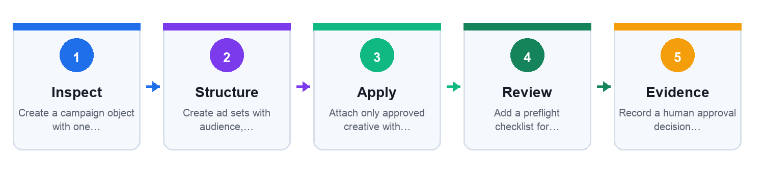

Before you begin
Open the individual lab folder and inspect every file in mock_data/. Use only the supplied mock data. Create a working copy of each output artifact inside the same lab folder.

Detailed step-by-step procedure
- Create a campaign object with one outcome objective.
Evidence to retain for Step 1: the changed field, formula, decision rationale or approval record. Do not use a screenshot as a substitute for editable evidence.
- Create ad sets with audience, budget, schedule and suppression fields.
Evidence to retain for Step 2: the changed field, formula, decision rationale or approval record. Do not use a screenshot as a substitute for editable evidence.
- Attach only approved creative with valid usage rights.
Evidence to retain for Step 3: the changed field, formula, decision rationale or approval record. Do not use a screenshot as a substitute for editable evidence.
- Add a preflight checklist for destination, tracking and naming.
Evidence to retain for Step 4: the changed field, formula, decision rationale or approval record. Do not use a screenshot as a substitute for editable evidence.
- Record a human approval decision with reason and reviewer role.
Evidence to retain for Step 5: the changed field, formula, decision rationale or approval record. Do not use a screenshot as a substitute for editable evidence.
- Export a package for simulation only; do not publish.
Evidence to retain for Step 6: the changed field, formula, decision rationale or approval record. Do not use a screenshot as a substitute for editable evidence.

Test it — Verification
- Campaign, ad set and ad fields are at the correct hierarchy.
- Daily budget stays within SGD 250.
- Pending CR-03 is blocked.
- The package contains no live credential or account ID.

Troubleshooting
- If delivery settings conflict, trace which hierarchy owns the field.
- If a creative is blocked, check status and rights_expiry.

Cleanup
- Delete any accidental real account identifiers.
- Keep the approved simulation package and decision log.
Full lab folder: labs/lab-04-campaign-builder/

5. Topic 03: Measure Performance and Agent Decisions
WSQ mapping: A3 · K5 · K6. Legacy coverage retained: Measure Facebook Social Media Marketing Performance.

Map the Measurement Event Pipeline
Technical anchor: ARCH · A3. The mechanism runs through Impression → Click → Session → Conversion → Reconcile.
Field | Worked value | Interpretation
event_name | lead_submitted | Stable taxonomy
event_time | ISO-8601 | Sequence
campaign_id | CMP-26-04 | Join key
value | 120.00 SGD | Outcome value

Failure, control and recovery
Failure mode | Observable signal | Control / recovery
Duplicate event | Inflated conversions | event_id dedupe
Missing consent | Illegal collection | Consent gate
Clock drift | Wrong attribution | UTC timestamps
Join failure | No campaign ID | Required key
Worked evidence: Loss between stages is expected; unexplained discontinuities are instrumentation defects.

Calculate Reach, CTR, CVR, CPL and ROAS
Technical anchor: FORMULA · A3. The mechanism runs through Reach → CTR → CVR → CPL → ROAS.
Field | Worked value | Interpretation
impressions | 50,000 | CTR denominator
clicks | 3,400 | CTR = 6.8%
leads | 96 | CVR = 2.82%
spend | SGD 2,400 | CPL = SGD 25

Failure, control and recovery
Failure mode | Observable signal | Control / recovery
Mixed windows | Spend and leads differ | Same date range
Wrong denominator | CVR uses impressions | Metric dictionary
Gross revenue | ROAS overstates margin | Add contribution margin
Tiny sample | Volatile rate | Show counts
Worked evidence: Rates are meaningful only when their underlying counts and windows are visible.

Build a Funnel with Diagnostic Rates
Technical anchor: MODEL · A3. The mechanism runs through Exposure → Interest → Intent → Lead → Value.
Field | Worked value | Interpretation
stage | lead | Named state
count | 96 | Observed total
rate_from_prior | 23.4% | Local conversion
drop_reason | form friction | Diagnosis

Failure, control and recovery
Failure mode | Observable signal | Control / recovery
Double counting | Repeated events | Unique key
Unknown loss | No reason codes | Instrument exits
Quality ignored | Cheap low-value leads | Qualification rate
Lag ignored | Recent leads not matured | Cohort window
Worked evidence: A low early-stage rate and a strong late-stage rate imply a targeting or creative issue.

Separate Attribution from Incrementality
Technical anchor: CASE · A3. The mechanism runs through Observed conversion → Attribution rule → Counterfactual → Experiment → Decision.
Field | Worked value | Interpretation
window | 7-day click | Attribution scope
credited | 120 | Reported conversions
holdout | 24 | Baseline conversions
incremental | 96 | Estimated lift

Failure, control and recovery
Failure mode | Observable signal | Control / recovery
Last-click bias | Upper funnel erased | Compare models
View-through inflation | Passive exposure credited | Separate view/click
No counterfactual | Correlation claimed causal | Holdout
Cross-device gap | Identity incomplete | State limitation
Worked evidence: Attributed conversions can exceed estimated incremental conversions.

Design a Reporting Schema for Agents
Technical anchor: SCHEMA · K8/A3. The mechanism runs through Extract → Normalize → Compute → Explain → Deliver.
Field | Worked value | Interpretation
report_date | 2026-09-11 | As-of time
currency | SGD | Comparable spend
formula_version | metrics-v2 | Reproducibility
source_rows | campaign.csv:48 | Lineage

Failure, control and recovery
Failure mode | Observable signal | Control / recovery
Silent refresh | Numbers change | Snapshot timestamp
Schema drift | Column renamed | Validation
Rounding error | Totals disagree | Compute then format
Narrative hallucination | Claim lacks row | Evidence citation
Worked evidence: Automation can reduce preparation time while review and sign-off remain explicit.

Detect Anomalies with Thresholds and Context
Technical anchor: FORMULA · A3. The mechanism runs through Baseline → Band → Trigger → Context → Escalate.
Field | Worked value | Interpretation
metric | CPL | Signal
baseline | SGD 22 | Reference
threshold | > SGD 30 | Trigger
severity | high | Routing

Failure, control and recovery
Failure mode | Observable signal | Control / recovery
Seasonality | Normal spike flagged | Comparable baseline
Alert flood | Every metric triggers | Priority tiers
Auto-pause harm | False positive stops winner | Human approval
No context | Budget change ignored | Event annotations
Worked evidence: The final-day spike breaches the SGD 30 decision threshold and needs diagnosis.

Build Retargeting with Consent and Suppression
Technical anchor: CONTROL · K5/A3. The mechanism runs through Qualify → Segment → Suppress → Sequence → Expire.
Field | Worked value | Interpretation
segment | cart_7d | Behavior cohort
consent | true | Eligibility
suppression | purchased_30d | Exclusion
ttl_days | 7 | Expiry

Failure, control and recovery
Failure mode | Observable signal | Control / recovery
No suppression | Customers see acquisition ad | Exclude converters
Long retention | Stale tracking | TTL
Sensitive proxy | Inferred condition | Prohibited features
Frequency harm | Excess exposure | Cap and monitor
Worked evidence: Consent, suppression, and freshness filters reduce the addressable group.

Observe the Agent, Not Just the Campaign
Technical anchor: EVIDENCE · A3. The mechanism runs through Trace → Record → Score → Review → Improve.
Field | Worked value | Interpretation
trace_id | run-0911-042 | Correlation
tool_calls | 6 | Action count
policy_flags | 1 | Risk signal
final_status | approved | Outcome

Failure, control and recovery
Failure mode | Observable signal | Control / recovery
No trace | Cannot reproduce | Mandatory run ID
Sensitive logs | PII retained | Redaction
Success-only metrics | Failures hidden | All outcomes
Unsafe learning | Bad output saved | Reviewed memory
Worked evidence: Approval, revision, validation failure, and escalation should be tracked separately.

Lab 5: Compute a Campaign Measurement Scorecard
Mappings: LO3 · A3 · K5 · K8

Goal
Use the supplied mock data to produce scorecard.csv, metric_dictionary.md and funnel_analysis.md and demonstrate the mapped abilities under human oversight.

Scenario and deliverable
Reconcile a mock platform export and CRM outcome table, then calculate decision-ready metrics.
Produce: scorecard.csv, metric_dictionary.md and funnel_analysis.md
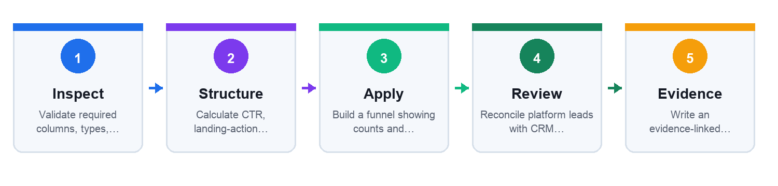

Before you begin
Open the individual lab folder and inspect every file in mock_data/. Use only the supplied mock data. Create a working copy of each output artifact inside the same lab folder.

Detailed step-by-step procedure
- Validate required columns, types, currency and date window.
Evidence to retain for Step 1: the changed field, formula, decision rationale or approval record. Do not use a screenshot as a substitute for editable evidence.
- Calculate CTR, landing-action rate, CVR, CPL and ROAS.
Evidence to retain for Step 2: the changed field, formula, decision rationale or approval record. Do not use a screenshot as a substitute for editable evidence.
- Build a funnel showing counts and stage-to-stage rates.
Evidence to retain for Step 3: the changed field, formula, decision rationale or approval record. Do not use a screenshot as a substitute for editable evidence.
- Reconcile platform leads with CRM quality outcomes.
Evidence to retain for Step 4: the changed field, formula, decision rationale or approval record. Do not use a screenshot as a substitute for editable evidence.
- Write an evidence-linked interpretation with limitations.
Evidence to retain for Step 5: the changed field, formula, decision rationale or approval record. Do not use a screenshot as a substitute for editable evidence.
- Define scale, hold and stop decision rules.
Evidence to retain for Step 6: the changed field, formula, decision rationale or approval record. Do not use a screenshot as a substitute for editable evidence.

Test it — Verification
- CTR equals clicks divided by impressions.
- CPL equals spend divided by leads.
- ROAS is clearly labeled as revenue/ad spend.
- Every narrative claim cites a computed row.

Troubleshooting
- If totals disagree, confirm the same campaign and date window.
- If a rate is unstable, show its raw count and avoid overclaiming.

Cleanup
- Remove any formula scratch sheets with broken references.
- Retain the clean input, metric dictionary and scorecard.
Full lab folder: labs/lab-05-measurement-scorecard/

Lab 6: Build a Listening and Anomaly Triage Agent
Mappings: LO3 · A3 · K8 · K10

Goal
Use the supplied mock data to produce alerts.csv and incident_triage.md and demonstrate the mapped abilities under human oversight.

Scenario and deliverable
Detect a CPL spike and rising negative feedback without allowing the agent to pause live campaigns automatically.
Produce: alerts.csv and incident_triage.md
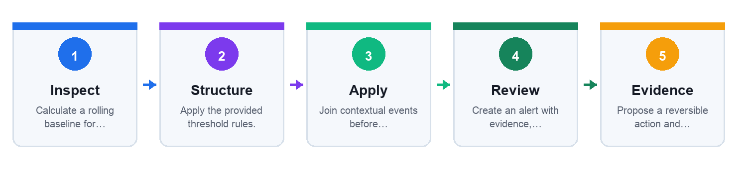

Before you begin
Open the individual lab folder and inspect every file in mock_data/. Use only the supplied mock data. Create a working copy of each output artifact inside the same lab folder.

Detailed step-by-step procedure
- Calculate a rolling baseline for each signal.
Evidence to retain for Step 1: the changed field, formula, decision rationale or approval record. Do not use a screenshot as a substitute for editable evidence.
- Apply the provided threshold rules.
Evidence to retain for Step 2: the changed field, formula, decision rationale or approval record. Do not use a screenshot as a substitute for editable evidence.
- Join contextual events before assigning likely cause.
Evidence to retain for Step 3: the changed field, formula, decision rationale or approval record. Do not use a screenshot as a substitute for editable evidence.
- Create an alert with evidence, severity and owner.
Evidence to retain for Step 4: the changed field, formula, decision rationale or approval record. Do not use a screenshot as a substitute for editable evidence.
- Propose a reversible action and rollback condition.
Evidence to retain for Step 5: the changed field, formula, decision rationale or approval record. Do not use a screenshot as a substitute for editable evidence.
- Record that a human—not the agent—decides whether to pause.
Evidence to retain for Step 6: the changed field, formula, decision rationale or approval record. Do not use a screenshot as a substitute for editable evidence.

Test it — Verification
- The 2026-09-05 CPL and comment alerts fire.
- The budget increase is retained as context.
- No rule authorizes automatic campaign pause.
- The alert includes source rows and owner.

Troubleshooting
- If every day alerts, compare against a stable baseline and tune severity.
- If no alert fires, check numeric types and operators.

Cleanup
- Delete test alerts marked as real incidents.
- Retain the rules, mock data and final triage record.
Full lab folder: labs/lab-06-listening-anomaly-agent/

6. Topic 04: Optimize Campaigns with Controlled Experiments
WSQ mapping: A4 · K7 · K8. Legacy coverage retained: Optimize Facebook Social Media Marketing Performance.

Run the Observe–Diagnose–Act Loop
Technical anchor: RUNTIME · K7/A4. The mechanism runs through Observe → Diagnose → Propose → Approve → Measure.
Field | Worked value | Interpretation
signal | CTR -22% | Observed change
hypothesis | creative fatigue | Diagnosis
action | rotate variant B | Intervention
rollback | CTR < baseline | Safety

Failure, control and recovery
Failure mode | Observable signal | Control / recovery
Metric chasing | Changes daily | Minimum window
Wrong diagnosis | Budget cut for tracking bug | Data health first
Large action | 100% reallocation | Bounded step
No rollback | Loss compounds | Precommit rule
Worked evidence: Automation shortens observation and diagnosis but approval remains deliberate.

Use Practical Significance in A/B Decisions
Technical anchor: FORMULA · K7/A4. The mechanism runs through Set baseline → Set minimum lift → Collect sample → Compare → Decide.
Field | Worked value | Interpretation
baseline_cvr | 4.8% | Control
variant_cvr | 5.3% | Observed
relative_lift | 10.4% | Effect
min_lift | 10% | Business threshold

Failure, control and recovery
Failure mode | Observable signal | Control / recovery
Stat-only win | Tiny useless lift | Practical threshold
Underpowered | Wide uncertainty | Extend sample
Metric switch | Choose winner after seeing data | Pre-register
Segment mining | False positives | Limit comparisons
Worked evidence: The observed lift barely clears the business threshold; uncertainty still matters.

Reallocate Budget with Marginal Return
Technical anchor: FORMULA · A4. The mechanism runs through Measure → Estimate → Rank → Move → Recheck.
Field | Worked value | Interpretation
channel | retargeting | Budget pool
marginal_cpl | SGD 18 | Next-dollar cost
max_shift | 15% | Change bound
review_after | 48 hours | Stability

Failure, control and recovery
Failure mode | Observable signal | Control / recovery
Average return | Hides saturation | Use marginal
Large shift | Resets learning | Cap change
Delayed value | Leads not matured | Cohort lag
Automated overspend | No hard ceiling | Account budget cap
Worked evidence: Budget should move toward the lowest marginal CPL within delivery and risk constraints.

Detect Creative Fatigue
Technical anchor: EVIDENCE · K7/A4. The mechanism runs through Track → Compare → Confirm → Rotate → Learn.
Field | Worked value | Interpretation
frequency | 4.6 | Exposure load
ctr_change | -28% | Response decay
comment_tone | negative rising | Qualitative signal
action | rotate | Decision

Failure, control and recovery
Failure mode | Observable signal | Control / recovery
False fatigue | Tracking outage | Data health check
Audience depletion | Small pool | Broaden carefully
Unapproved asset | Fast rotation skips review | Preapproved library
Learning loss | Old asset deleted | Archive version
Worked evidence: Declining CTR as frequency rises is a fatigue signal, not proof by itself.

Control Audience Overlap and Frequency
Technical anchor: MODEL · K7/A4. The mechanism runs through Map → Estimate overlap → Prioritize → Exclude → Monitor.
Field | Worked value | Interpretation
audience_a | prospects_sg | Primary
audience_b | site_30d | Retarget
overlap | 38% | Conflict signal
frequency_cap | 3/7d | Exposure guard

Failure, control and recovery
Failure mode | Observable signal | Control / recovery
Self-competition | CPM rises | Mutual exclusions
Overexposure | Negative feedback | Frequency guard
Too narrow | Delivery stalls | Minimum size
Proxy targeting | Fairness risk | Feature review
Worked evidence: The 38% pair needs exclusions or a clear prioritization rule.

Schedule Content with Dependencies
Technical anchor: CONFIG · K8/A4. The mechanism runs through Backlog → Calendar → Dependency → Publish → Reconcile.
Field | Worked value | Interpretation
content_id | CNT-118 | Stable item
publish_at | 2026-09-15T10:00+08 | Timezone
dependency | legal-approved | Gate
request_id | pub-118-v2 | No duplicates

Failure, control and recovery
Failure mode | Observable signal | Control / recovery
Timezone error | Publishes eight hours late | Explicit offset
Duplicate post | Retry creates copy | Idempotency
Expired creative | Promotion ended | Validity window
Missing approval | Queue bypass | Hard dependency
Worked evidence: Education, proof, community, and promotion should reflect the campaign objective.

Compare Platforms with a Feasibility Matrix
Technical anchor: MODEL · K3/A4. The mechanism runs through Need → Criteria → Evidence → Score → Pilot.
Field | Worked value | Interpretation
platform | Facebook | Option
audience_fit | 4/5 | Evidence score
measurement | 4/5 | Data capability
pilot_budget | SGD 500 | Reversible test

Failure, control and recovery
Failure mode | Observable signal | Control / recovery
Popularity bias | Largest platform wins | Outcome weighting
Stale demographics | Old report used | As-of date
Apples/oranges | Different KPIs | Common outcome
Full rollout | No pilot | Test first
Worked evidence: Platform choice combines fit, measurement, format, cost, and governance—not reach alone.

Define Rollback and Kill-Switch Rules
Technical anchor: CONTROL · K2/A4. The mechanism runs through Bound → Trigger → Pause → Restore → Review.
Field | Worked value | Interpretation
max_daily_spend | SGD 250 | Hard ceiling
kill_trigger | policy_severity=critical | Immediate stop
rollback_version | campaign-v8 | Known good
owner | marketing_director | Authority

Failure, control and recovery
Failure mode | Observable signal | Control / recovery
Soft limit | Agent overrides | Enforce externally
No snapshot | Cannot restore | Version configuration
Broad kill | All campaigns paused | Scope by campaign
Restart loop | Failure repeats | Human reopen
Worked evidence: Spend, CPL, budget-shift, and critical-policy thresholds constrain autonomy.

Lab 7: Evaluate an A/B Test and Budget Decision
Mappings: LO4 · A4 · K7

Goal
Use the supplied mock data to produce experiment_decision.md and budget_change.json and demonstrate the mapped abilities under human oversight.

Scenario and deliverable
Determine whether creative B should receive more budget without reacting to an early, unstable result.
Produce: experiment_decision.md and budget_change.json
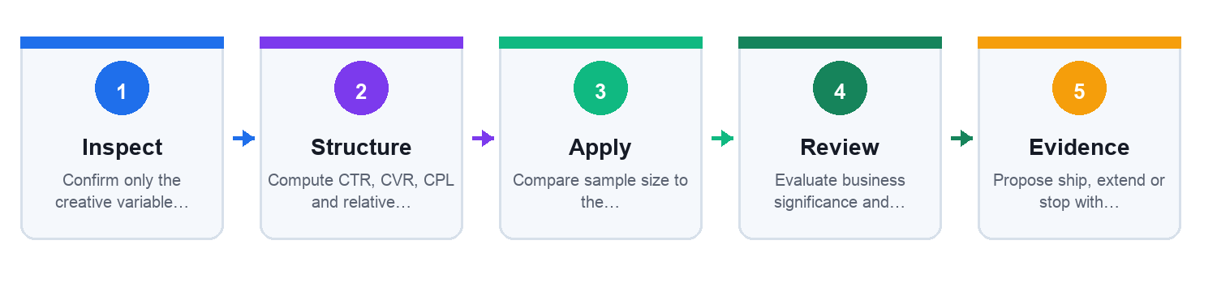

Before you begin
Open the individual lab folder and inspect every file in mock_data/. Use only the supplied mock data. Create a working copy of each output artifact inside the same lab folder.

Detailed step-by-step procedure
- Confirm only the creative variable differs.
Evidence to retain for Step 1: the changed field, formula, decision rationale or approval record. Do not use a screenshot as a substitute for editable evidence.
- Compute CTR, CVR, CPL and relative lift for both cells.
Evidence to retain for Step 2: the changed field, formula, decision rationale or approval record. Do not use a screenshot as a substitute for editable evidence.
- Compare sample size to the precommitted rule.
Evidence to retain for Step 3: the changed field, formula, decision rationale or approval record. Do not use a screenshot as a substitute for editable evidence.
- Evaluate business significance and uncertainty.
Evidence to retain for Step 4: the changed field, formula, decision rationale or approval record. Do not use a screenshot as a substitute for editable evidence.
- Propose ship, extend or stop with rationale.
Evidence to retain for Step 5: the changed field, formula, decision rationale or approval record. Do not use a screenshot as a substitute for editable evidence.
- If shipping, create a bounded budget change and rollback rule.
Evidence to retain for Step 6: the changed field, formula, decision rationale or approval record. Do not use a screenshot as a substitute for editable evidence.

Test it — Verification
- Both cells exceed 500 clicks.
- Relative CVR lift is calculated from the control baseline.
- Budget change does not exceed 15%.
- The decision states evidence and uncertainty.

Troubleshooting
- If the lift looks huge, verify percentages use the correct denominator.
- If the test changed multiple variables, mark the causal conclusion invalid.

Cleanup
- Remove exploratory metrics chosen after the result.
- Retain the precommitted policy and final decision.
Full lab folder: labs/lab-07-ab-test-optimizer/

Lab 8: Orchestrate an Approval-Aware Content Calendar
Mappings: LO4 · A4 · K4 · K8

Goal
Use the supplied mock data to produce approved_calendar.csv and exception_queue.csv and demonstrate the mapped abilities under human oversight.

Scenario and deliverable
Schedule an eight-item campaign calendar with timezones, dependencies, rights expiry and idempotent publishing requests.
Produce: approved_calendar.csv and exception_queue.csv
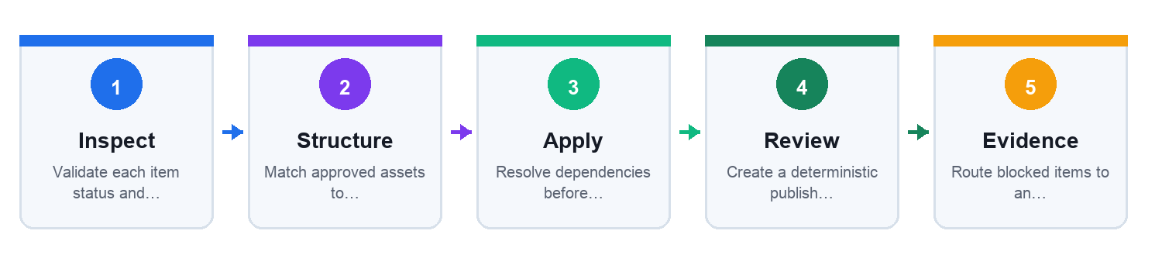

Before you begin
Open the individual lab folder and inspect every file in mock_data/. Use only the supplied mock data. Create a working copy of each output artifact inside the same lab folder.

Detailed step-by-step procedure
- Validate each item status and validity window.
Evidence to retain for Step 1: the changed field, formula, decision rationale or approval record. Do not use a screenshot as a substitute for editable evidence.
- Match approved assets to compatible slots and formats.
Evidence to retain for Step 2: the changed field, formula, decision rationale or approval record. Do not use a screenshot as a substitute for editable evidence.
- Resolve dependencies before scheduling.
Evidence to retain for Step 3: the changed field, formula, decision rationale or approval record. Do not use a screenshot as a substitute for editable evidence.
- Create a deterministic publish request_id.
Evidence to retain for Step 4: the changed field, formula, decision rationale or approval record. Do not use a screenshot as a substitute for editable evidence.
- Route blocked items to an exception queue.
Evidence to retain for Step 5: the changed field, formula, decision rationale or approval record. Do not use a screenshot as a substitute for editable evidence.
- Reconcile the planned schedule with mock actual post IDs.
Evidence to retain for Step 6: the changed field, formula, decision rationale or approval record. Do not use a screenshot as a substitute for editable evidence.

Test it — Verification
- Pending CNT-103 is not scheduled.
- All timestamps include +08:00.
- No content is scheduled after valid_to.
- Every scheduled row has a unique request_id.

Troubleshooting
- If a duplicate appears, check request_id construction.
- If a slot is empty, inspect approval, rights and format constraints.

Cleanup
- Remove any live webhook or platform credentials.
- Retain the final calendar and exception queue.
Full lab folder: labs/lab-08-content-calendar-orchestrator/

7. Topic 05: Manage Communities with Human Oversight
WSQ mapping: A5 · A6 · K9 · K10. Legacy coverage retained: Manage Facebook Social Media Community.

Route Community Messages by Intent and Risk
Technical anchor: RUNTIME · K9/K10. The mechanism runs through Ingest → Classify → Score → Route → Close.
Field | Worked value | Interpretation
intent | delivery_issue | Work queue
sentiment | negative | Context
risk_score | 0.82 | Escalation
sla_minutes | 30 | Response target

Failure, control and recovery
Failure mode | Observable signal | Control / recovery
Sarcasm | Sentiment misread | Human review
Private data | Order number public | Move to private channel
Wrong queue | Crisis treated routine | Severity rules
No closure | Repeated complaint | Case status
Worked evidence: Routine, assisted, escalated, and rejected items need distinct workflows.

Evaluate Sentiment with Confidence
Technical anchor: MODEL · K10/A5. The mechanism runs through Normalize → Classify → Estimate → Sample → Adjust.
Field | Worked value | Interpretation
label | negative | Prediction
confidence | 0.64 | Uncertainty
language | en-SG | Context
review | required | Low-confidence route

Failure, control and recovery
Failure mode | Observable signal | Control / recovery
Dialect error | Singlish misread | Local sample
Aggregate masking | Crisis subgroup hidden | Segment view
Confidence misuse | 0.51 auto-action | Threshold
Feedback leakage | Reviewer label includes PII | Redact
Worked evidence: Distribution is a signal; confidence and representative sampling determine trust.

Apply a Moderation Decision Ladder
Technical anchor: CONTROL · K9/K10. The mechanism runs through Allow → Assist → Review → Escalate → Remove.
Field | Worked value | Interpretation
policy_code | HARASS-02 | Rule
severity | high | Priority
evidence_hash | sha256:… | Integrity
decision | escalate | Outcome

Failure, control and recovery
Failure mode | Observable signal | Control / recovery
Over-removal | Legitimate criticism hidden | Appeal route
Under-removal | Harm remains | High-risk threshold
Context loss | Quoted slur punished | Conversation window
No evidence | Decision disputed | Capture snapshot
Worked evidence: Most content remains visible; sensitive decisions need evidence and appeal.

Manage UGC Rights and Permissions
Technical anchor: ARTIFACT · K6/K10. The mechanism runs through Discover → Request → Record → Credit → Expire.
Field | Worked value | Interpretation
ugc_id | UGC-204 | Asset key
creator | @sample_creator | Rights holder
channels | Facebook, Instagram | Licensed scope
expires | 2026-12-31 | Term

Failure, control and recovery
Failure mode | Observable signal | Control / recovery
Hashtag assumption | Tag treated as permission | Ask explicitly
Scope creep | Use in paid ad | Record channels
Missing credit | Creator omitted | Attribution field
Expired right | Asset still scheduled | Calendar validation
Worked evidence: Approved, pending, declined, and expired assets must remain distinguishable.

Escalate Reputation Risk with Evidence
Technical anchor: CASE · K9/A5. The mechanism runs through Detect → Verify → Contain → Respond → Review.
Field | Worked value | Interpretation
mentions_15m | 84 | Velocity
severity | critical | Priority
owner | communications_lead | Authority
next_update | 30 min | Cadence

Failure, control and recovery
Failure mode | Observable signal | Control / recovery
Auto-defence | Agent argues publicly | Pause replies
Slow escalation | Issue compounds | Velocity trigger
Unverified claim | Rumor repeated | Source check
No timeline | Conflicting updates | Incident log
Worked evidence: Acceleration, not just volume, can trigger a crisis escalation.

Build an Advocacy Flywheel
Technical anchor: MODEL · K9/A5. The mechanism runs through Listen → Recognize → Enable → Amplify → Measure.
Field | Worked value | Interpretation
advocate_id | ADV-031 | Relationship key
contribution | tutorial video | Value
permission | organic repost | Scope
referrals | 7 | Outcome

Failure, control and recovery
Failure mode | Observable signal | Control / recovery
Transactional reward | Community feels bought | Value exchange
Favoritism | Same voices amplified | Diversity review
Consent gap | Repost without permission | Rights record
Vanity advocacy | Reach only | Retention/referral
Worked evidence: Recognition can progress from contributors to repeat advocates and referrals.

Evaluate Organisational Impact
Technical anchor: FORMULA · A5/A6. The mechanism runs through Define → Baseline → Measure → Attribute → Decide.
Field | Worked value | Interpretation
revenue_lift | SGD 18,000 | Outcome
cost | SGD 7,200 | Investment
complaint_rate | 1.8% | Guardrail
confidence | medium | Evidence strength

Failure, control and recovery
Failure mode | Observable signal | Control / recovery
Single metric | Sales rise, trust falls | Balanced scorecard
No counterfactual | All lift credited | State limits
Hidden labor | Review time ignored | Full cost
Short window | No retention view | Cohort follow-up
Worked evidence: Financial value, cost, satisfaction lift, and complaint rate tell different parts of impact.

Operate an AI Governance and Oversight Loop
Technical anchor: GOVERNANCE · K2/K5/A5. The mechanism runs through Register → Assess → Control → Monitor → Retire.
Field | Worked value | Interpretation
use_case_id | AI-SMM-01 | Inventory
risk_tier | medium | Control depth
human_owner | marketing_director | Accountability
review_cycle | quarterly | Oversight

Failure, control and recovery
Failure mode | Observable signal | Control / recovery
Shadow agent | No registered owner | Inventory
Data drift | Audience changes | Monitoring
Vendor change | Behavior shifts | Change review
Zombie access | Retired tool active | Revoke credentials
Worked evidence: Registration, risk assessment, control testing, and review completion form an evidence chain.

Lab 9: Triage Community Messages with Human Oversight
Mappings: LO5 · A5 · K5 · K9 · K10

Goal
Use the supplied mock data to produce moderation_queue.csv and response_log.md and demonstrate the mapped abilities under human oversight.

Scenario and deliverable
Classify and route a queue of comments while protecting personal data and preserving legitimate criticism.
Produce: moderation_queue.csv and response_log.md
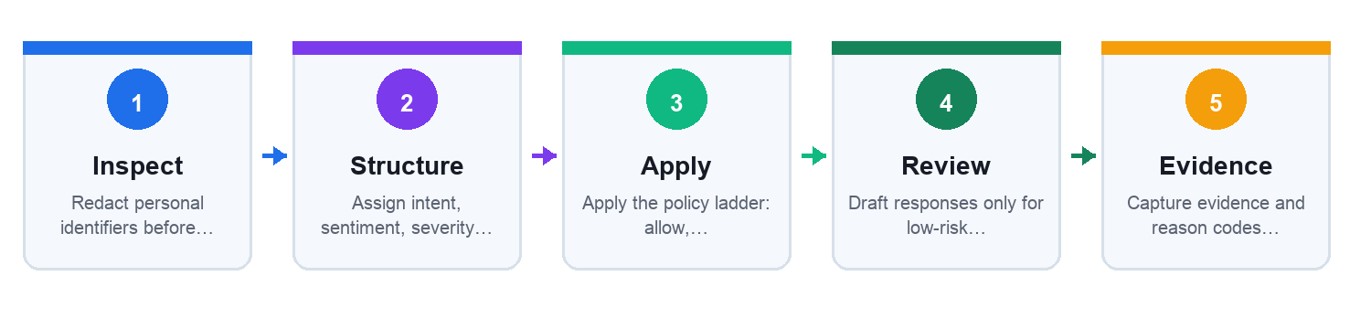

Before you begin
Open the individual lab folder and inspect every file in mock_data/. Use only the supplied mock data. Create a working copy of each output artifact inside the same lab folder.

Detailed step-by-step procedure
- Redact personal identifiers before AI-assisted classification.
Evidence to retain for Step 1: the changed field, formula, decision rationale or approval record. Do not use a screenshot as a substitute for editable evidence.
- Assign intent, sentiment, severity and confidence.
Evidence to retain for Step 2: the changed field, formula, decision rationale or approval record. Do not use a screenshot as a substitute for editable evidence.
- Apply the policy ladder: allow, assist, review, escalate or remove.
Evidence to retain for Step 3: the changed field, formula, decision rationale or approval record. Do not use a screenshot as a substitute for editable evidence.
- Draft responses only for low-risk items.
Evidence to retain for Step 4: the changed field, formula, decision rationale or approval record. Do not use a screenshot as a substitute for editable evidence.
- Capture evidence and reason codes for sensitive decisions.
Evidence to retain for Step 5: the changed field, formula, decision rationale or approval record. Do not use a screenshot as a substitute for editable evidence.
- Review a sample for false positives and local-language errors.
Evidence to retain for Step 6: the changed field, formula, decision rationale or approval record. Do not use a screenshot as a substitute for editable evidence.

Test it — Verification
- Order number in M002 is redacted before processing.
- M004 is emergency-escalated and not auto-replied.
- M003 remains visible while routed for human review.
- Every decision has a reason code.

Troubleshooting
- If sarcasm or dialect is uncertain, lower confidence and route to review.
- If criticism is removed merely for being negative, revisit the policy criterion.

Cleanup
- Delete unredacted scratch copies.
- Retain only the redacted queue and evidence log.
Full lab folder: labs/lab-09-community-moderation-agent/

Lab 10: Capstone: Operate a Governed Agentic Campaign
Mappings: LO1–LO6 · A1–A6 · K1–K10

Goal
Use the supplied mock data to produce campaign_runbook.md, governance_register.csv and executive_review.md and demonstrate the mapped abilities under human oversight.

Scenario and deliverable
Integrate planning, creation, measurement, optimization and community controls into one auditable Lumina Living campaign runbook.
Produce: campaign_runbook.md, governance_register.csv and executive_review.md
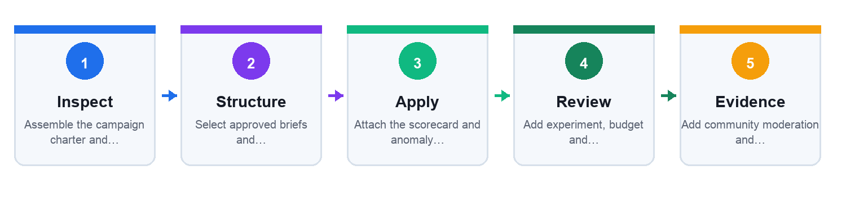

Before you begin
Open the individual lab folder and inspect every file in mock_data/. Use only the supplied mock data. Create a working copy of each output artifact inside the same lab folder.

Detailed step-by-step procedure
- Assemble the campaign charter and persona evidence from Labs 1–2.
Evidence to retain for Step 1: the changed field, formula, decision rationale or approval record. Do not use a screenshot as a substitute for editable evidence.
- Select approved briefs and campaign configuration from Labs 3–4.
Evidence to retain for Step 2: the changed field, formula, decision rationale or approval record. Do not use a screenshot as a substitute for editable evidence.
- Attach the scorecard and anomaly rules from Labs 5–6.
Evidence to retain for Step 3: the changed field, formula, decision rationale or approval record. Do not use a screenshot as a substitute for editable evidence.
- Add experiment, budget and calendar controls from Labs 7–8.
Evidence to retain for Step 4: the changed field, formula, decision rationale or approval record. Do not use a screenshot as a substitute for editable evidence.
- Add community moderation and crisis escalation from Lab 9.
Evidence to retain for Step 5: the changed field, formula, decision rationale or approval record. Do not use a screenshot as a substitute for editable evidence.
- Run a tabletop simulation and record human decisions, failures and rollback actions.
Evidence to retain for Step 6: the changed field, formula, decision rationale or approval record. Do not use a screenshot as a substitute for editable evidence.
- Write an executive review covering value, risk, evidence and next action.
Evidence to retain for Step 7: the changed field, formula, decision rationale or approval record. Do not use a screenshot as a substitute for editable evidence.

Test it — Verification
- Every agent action has an owner, input, output and control.
- All six abilities and ten knowledge criteria are evidenced.
- No live credentials or personal data exist in the package.
- The runbook contains a kill switch, rollback version and incident route.

Troubleshooting
- If an artifact cannot be traced, add its source lab and version.
- If the agent can publish or pause without approval, narrow its tool contract.

Cleanup
- Remove all real names, credentials and platform account IDs.
- Archive one final immutable capstone package for assessment evidence.
Full lab folder: labs/lab-10-capstone-agentic-campaign/

8. Capstone Evidence Checklist
- Objectives and KPI rules are measurable.
- Persona and audience claims have provenance and confidence.
- Campaign objects respect hierarchy and policy.
- Every generated claim cites approved evidence.
- Metrics use consistent windows and denominators.
- Optimization changes are bounded and reversible.
- Community decisions preserve privacy, rights and appeal.
- Human decisions and agent actions are traceable.

9. Sources and Version Notes
- Legacy coverage: WSQ Master Trainer Slides v14 supplied in reference/
- QuickBook: Agent-Powered Growth, John Wiley & Sons, 2026 — architecture, deployment and scaling concepts paraphrased
- QuickBook: AI in Marketing: Applications, Insights, and Analysis, Routledge, 2025 — applications, consumer insight and ethics concepts paraphrased
- Course page: https://www.tertiarycourses.com.sg/wsq-agentic-ai-for-social-media-marketing.html
- Meta for Business: https://www.facebook.com/business/ads/facebook-instagram-reels-ads
- PDPC obligations: https://www.pdpc.gov.sg/overview-of-pdpa/the-legislation/personal-data-protection-act/data-protection-obligations

